PROJECT TITLE

TRAVEL WORLD
Tour & Travel Management System
Submitted by
VISHALISHREE - RA2311008020137
AKSHANA JEBERSON - RA23110080
SRIDEVI - RA2311008020177
Under the guidance of

MR. MOHAN KUMAR
[Mentor from LEARN SQUARE]



RAMAPURAM, CHENNAI-600089

DECEMBER 2025
TABLE OF CONTENTS

Chapter No. | Title | Page No.
1 | INTRODUCTION | 3
2 | ABSTRACT | 4
3 | PURPOSE OF THE PROJECT | 5
4 | SCOPE OF THE PROJECT | 6
5 | LITERATURE SURVEY | 6
7 | LIMITATIONS OF EXISTING PROJECT | 7
8 | MOTIVATION FOR THE PROPOSED SYSTEM | 7
9 | PROBLEM STATEMENT | 8
10 | OBJECTIVES OF THE SYSTEM | 9
11 | SYSTEM REQUIREMENTS | 10
12 | SYSTEM ARCHITECTURE | 11
13 | MODULE DESCRIPTION | 12
14 | DATABASE DESIGN | 14
15 | IMPLEMENTATION DETAILS | 14
16 | TESTING AND VALIDATION | 14
17 | ADVANTAGES OF THE SYSTEM | 15
18 | LIMITATIONS | 15
19 | FUTURE ENHANCEMENTS | 15
20 | CONCLUSION | 16
21 | SOURCE CODE | 17
22 | OUTPUT SCREENSHOTS | 26
23 | REFERENCES | 29

Introduction

The Travel and Tourism industry plays a crucial role in the global economy by generating employment opportunities and contributing significantly to national income and economic growth. Over the years, tourism has evolved into a highly competitive and technology-driven sector. With the rapid advancement of digital technologies and the widespread use of the internet, traditional travel booking methods have gradually transitioned from manual and offline processes to online platforms. Modern customers prefer browsing travel destinations, comparing tour packages, and making informed travel decisions through web-based applications rather than visiting physical travel agencies.
In this digital era, web-based tourism systems offer convenience, accessibility, and efficiency to both customers and service providers. Online platforms allow users to explore destinations, check package details, and plan their trips from anywhere at any time. However, managing large volumes of travel data manually becomes challenging for travel agencies, highlighting the need for an automated and centralized system.
The Travel World project is a Python-based Tourism Management System designed to address these challenges by providing a structured and centralized platform for managing travel destinations, tour packages, and bookings. The system enables users to explore a wide range of travel destinations, view detailed package information such as pricing and duration, and submit booking requests through an interactive and user-friendly web interface. This enhances user engagement and improves overall customer experience.
In addition to user functionalities, the project includes a dedicated Admin panel that allows administrators to efficiently manage destinations, update tour packages, and monitor booking details. This centralized administrative control reduces manual effort, minimizes errors, and ensures accurate data management. The project effectively demonstrates the application of Python in real-world web development by integrating backend logic, database connectivity, and frontend design. Overall, Travel World serves as a complete tourism management solution suitable for both academic learning and practical implementation.

Abstract
The rapid growth of digital technologies has significantly transformed the travel and tourism industry by shifting traditional booking methods to online platforms. In this context, the Travel World project is developed as a Python-based Tourism Management System that provides an efficient and user-friendly solution for managing travel destinations, tour packages, and bookings. The primary objective of the system is to automate tourism-related activities and offer a centralized platform for both users and administrators.
The system allows users to explore various travel destinations, view detailed tour package information, and submit booking requests through an interactive web interface. At the same time, an Admin panel is provided to manage destinations, update packages, and monitor booking details efficiently. The backend of the system is implemented using Python with a web framework, while frontend technologies such as HTML, CSS, and Bootstrap are used to create a responsive and attractive user interface. A relational database is used to store and manage travel-related data securely.
The Travel World project demonstrates the practical application of Python in web application development and highlights the integration of backend logic, database connectivity, and frontend design. The system reduces manual effort, improves data accuracy, and enhances customer experience. Overall, the project serves as a scalable and effective tourism management solution while also providing valuable learning experience in Python programming and software development.

Purpose of the Project

The primary purpose of the Travel World project is to design and develop a user-friendly web-based tourism management application that simplifies the process of managing tourism services in an efficient and organized manner. The project aims to bridge the gap between customers and travel service providers by offering a centralized digital platform that enables easy access to travel destinations, tour packages, and booking information. By replacing traditional manual processes with an automated system, the application improves accuracy, reduces workload, and enhances overall operational efficiency.
The Travel World system is designed to provide a smooth and interactive experience for users, allowing them to browse destinations, view detailed package information, and make booking requests with minimal effort. At the same time, the system empowers administrators with effective tools to manage destinations, update tour packages, and monitor booking details through a centralized Admin panel. This balanced design ensures improved coordination between customers and service providers while maintaining data consistency and reliability.
In addition to its functional goals, the project serves as an academic initiative aimed at strengthening practical knowledge in Python programming and web application development. Through this project, key technical concepts such as frontend–backend integration, database connectivity, CRUD operations, and Object-Oriented Programming principles are applied in a real-world scenario. The project also provides valuable insight into the Software Development Life Cycle (SDLC), including requirement analysis, system design, implementation, testing, and deployment. Overall, the Travel World project fulfills both practical and educational objectives, making it a valuable learning experience and an effective tourism management solution.

Scope of the Project

The scope of the Travel World system includes:
- Displaying popular travel destinations
- Providing detailed tour packages
- Managing booking details
- Admin control for updating data
- Scalable design for future enhancements
The system is suitable for small and medium-scale travel agencies and can be extended further to support online payments, user authentication, and mobile applications.

LITERATURE SURVEY

Existing Travel Management Systems
Several online travel platforms such as MakeMyTrip, Expedia, and TripAdvisor provide tourism-related services. However, most existing systems are:
- Complex for beginners
- Expensive to maintain
- Highly commercialized
- Difficult to customize
Many academic travel projects focus only on booking functionality and lack administrative control or structured data manag

Limitations of Existing Systems
Existing travel and tourism management systems, though widely used, suffer from several limitations that reduce their efficiency and usability, especially for small and medium-scale travel agencies. One of the major drawbacks of current systems is the lack of centralized administrative control. In many cases, travel data such as destinations, packages, and bookings are distributed across multiple platforms or managed through separate tools, making monitoring and updates difficult for administrators.
Another significant limitation is the presence of complex user interfaces. Many existing systems are designed with advanced features that are difficult for non-technical users to understand. This complexity often leads to confusion, increased training requirements, and reduced adoption by staff and customers. A poorly designed interface directly affects user experience and overall system effectiveness.
Existing systems also show a high dependency on third-party services such as payment gateways, external APIs, and cloud-based tools. While these services provide additional features, they increase system dependency and reduce control over core functionalities. Any failure or change in third-party services can disrupt the entire system operation.

Motivation for Proposed System

The Travel World project is motivated by the growing need for a simple, efficient, and user-friendly tourism management system that overcomes the limitations of existing solutions. The primary motivation behind this project is to design a system that centralizes travel data and provides complete administrative control while maintaining simplicity and ease of use.

Finally, the Travel World project is designed to be suitable for academic evaluation, meeting curriculum requirements and demonstrating key concepts such as Object-Oriented Programming, CRUD operations, and web application development. The project serves as an effective learning tool while providing a practical solution to tourism management challenges.

PROBLEM STATEMENT

Traditional travel agencies rely heavily on manual processes such as maintaining physical registers, spreadsheets, phone calls, and handwritten records to manage travel destinations, tour packages, and customer bookings. These conventional methods require significant human effort and consume a considerable amount of time, especially when handling a large volume of customer data. As a result, travel agencies often face difficulties in maintaining accurate records and responding efficiently to customer queries.
Manual data management methods are highly error-prone, leading to issues such as duplicate entries, incorrect booking details, and loss of important information. Updating travel packages or modifying booking details becomes a complex and tedious task, increasing the chances of inconsistency and data redundancy. Moreover, the absence of a centralized data storage system makes it difficult to retrieve information quickly, affecting decision-making and operational efficiency.
In the modern digital era, customers expect fast, reliable, and user-friendly online services. Traditional systems fail to provide a satisfactory user experience, as customers are required to depend on phone calls or in-person visits to obtain information about destinations and packages. This results in poor customer engagement and reduced satisfaction.
To overcome these challenges, there is a strong need for an automated tourism management system that centralizes travel-related data, reduces manual workload, improves customer experience, and ensures efficient data management. The Travel World project aims to address these issues by implementing a web-based tourism management system using Python, which provides a structured, scalable, and efficient solution for managing destinations, tour packages, and bookings through a centralized digital platform.

OBJECTIVES OF THE SYSTEM

Primary Objectives
✓ To design and develop a tourism management system using Python – to create a reliable and efficient web-based application for managing tourism-related activities.
✓ To provide an interactive user interface for browsing destinations – to allow users to explore travel destinations and packages easily through an attractive and user-friendly interface.
✓ To manage tour packages and bookings efficiently – to store, retrieve, and manage package and booking information in an organized manner.

Secondary Objectives
✓ To implement CRUD operations – to perform Create, Read, Update, and Delete operations on destinations, packages, and booking records.
✓ To apply Object-Oriented Programming (OOP) concepts – to improve code reusability, modularity, and maintainability of the system.
✓ To integrate database connectivity – to ensure secure and structured storage of data using a relational database.
✓ To ensure system scalability – to design the application in a way that allows future enhancements and feature expansion.

SYSTEM REQUIREMENTS

HARDWARE REQUIREMENTS
✓ Processor: Intel Core i3 or higher – required to efficiently execute Python backend logic and handle server-side operations.
✓ RAM: Minimum 4 GB – ensures smooth execution of the application and supports multitasking during development and testing.
✓ Storage: At least 20 GB of free disk space – required to store the operating system, project files, database, and development tools.
✓ Internet Connection: Required for installing required libraries, accessing documentation, and testing web functionalities.

SOFTWARE REQUIREMENTS
✓ Operating System: Windows – provides a stable platform for running Python and web development tools.
✓ Programming Language: Python 3.x – used for backend development, business logic, and database interaction.
✓ IDE: Visual Studio Code – used for writing, editing, and debugging the source code efficiently.
✓ Frontend Technologies: HTML, CSS, Bootstrap – used to design a responsive and user-friendly interface.
✓ Backend Framework: Flask – used to handle server-side processing and routing.
✓ Database: MySQL (XAMPP) – used for storing destinations, packages, and booking information.
✓ Web Browser: Google Chrome / Microsoft Edge – used for testing and accessing the application.

SYSTEM ARCHITECTURE
The system follows a three-tier architecture:
Presentation Layer
- User interface
- Handles user interaction
Application Layer
- Python backend logic
- Processes requests
- Communicates with database
Data Layer
- Stores destinations, packages, bookings
- Ensures data persistence
This architecture ensures modularity, scalability, and easy maintenance.

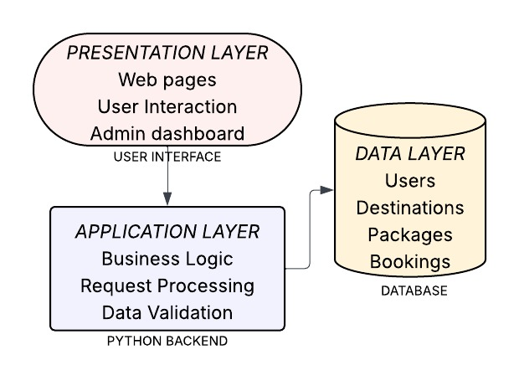

MODULE DESCRIPTION

User Module
The User Module allows users to:
- View destinations
- Browse tour packages
- View package details
- Submit booking requests
The module focuses on providing a smooth and attractive browsing experience.

Destination Module
This module manages:
- Destination name
- Country
- Category
- Description
- Ratings
Destinations such as Goa, Ooty, Paris, and Manali are displayed with detailed information.

Package Module
The Package Module includes:
- Package name
- Duration
- Price
- Group size
- Included facilities
This module helps users compare different travel options.

Booking Module
The Booking Module stores:
- User details
- Selected package
- Booking date
- Booking status
All booking data is stored securely in the database.

Admin Module
The Admin Module allows:
- Adding new destinations
- Updating packages
- Deleting outdated records
- Viewing booking reports
This module ensures complete system control.

DATABASE DESIGN
The database is designed using relational concepts.

Tables Used
- Users
- Destinations
- Packages
- Bookings
Each table is linked using primary and foreign keys to maintain data integrity.

IMPLEMENTATION DETAILS

The backend is implemented using Python, which handles:
- Routing
- Form handling
- Database operations
Frontend pages are created using HTML, CSS, and Bootstrap to ensure responsiveness.

TESTING

Types of Testing
- Unit Testing
- Integration Testing
- Functional Testing
- UI Testing
All modules were tested manually to ensure error-free execution.

RESULTS AND OUTPUT
The system successfully:
- Displays destinations and packages
- Stores booking information
- Allows admin data management
- Provides smooth navigation

ADVANTAGES OF THE SYSTEM
- Easy to use
- Time-saving
- Centralized management
- Cost-effective
- Scalable design

LIMITATIONS
- No online payment gateway
- No user authentication
- Limited UI animations

FUTURE ENHANCEMENTS
- Login & registration system
- Payment gateway integration
- Email notifications
- Review and rating system
- Mobile application

CONCLUSION

The Travel World project has been successfully designed and implemented as a Python-based Tourism Management System that simplifies the process of managing travel destinations, tour packages, and bookings through a centralized web platform. The primary objective of this project was to develop a user-friendly and efficient system that bridges the gap between travelers and travel service providers by offering an organized and digital approach to tourism management.
Throughout the development of this project, various software engineering principles and programming concepts were applied to ensure reliability, scalability, and ease of use. The system effectively integrates frontend technologies such as HTML, CSS, and Bootstrap with a robust Python backend, enabling smooth interaction between users and the database. By implementing structured modules such as Destination Management, Package Management, Booking Management, and Admin Control, the system provides a clear separation of functionalities and ensures better data handling.
The Travel World application allows users to explore multiple travel destinations, view detailed package information including price, duration, and facilities, and submit booking requests with minimal effort. At the same time, the Admin module empowers administrators to manage destinations, update packages, and monitor booking details efficiently. This centralized control reduces manual workload, minimizes errors, and improves overall system efficiency.
From an academic perspective, this project significantly enhanced practical knowledge in Python programming, web application development, database connectivity, and Object-Oriented Programming (OOP) concepts. It also provided hands-on experience in understanding the complete software development life cycle, from requirement analysis and system design to implementation, testing, and deployment.

SOURCE CODE

import os
from datetime import datetime
from flask import Flask, render_template, request, redirect, url_for, flash
from database import db, init_db
from models import Destination, Package, Customer, Booking

app = Flask(__name__)
app.secret_key = os.environ.get("SESSION_SECRET") or "travel-tourism-secret-key"

# Database configuration
app.config['SQLALCHEMY_DATABASE_URI'] = 'mysql+mysqlconnector://root:@localhost/voyage_portal'
app.config['SQLALCHEMY_TRACK_MODIFICATIONS'] = False

init_db(app)

with app.app_context():
db.create_all()

@app.route('/')
def index():
"""Home page with featured destinations and packages"""
featured_destinations = Destination.query.limit(6).all()
featured_packages = Package.query.filter_by(is_featured=True).limit(4).all()
return render_template('index.html',
destinations=featured_destinations,
packages=featured_packages)

@app.route('/destinations')
def destinations():
"""Browse all destinations with search and filter"""
search = request.args.get('search', '')
category = request.args.get('category', '')

query = Destination.query

if search:
query = query.filter(
(Destination.name.ilike(f'%{search}%')) |
(Destination.country.ilike(f'%{search}%'))
)

if category:
query = query.filter_by(category=category)

all_destinations = query.all()
categories = db.session.query(Destination.category).distinct().all()
categories = [c[0] for c in categories if c[0]]

return render_template('destinations.html',
destinations=all_destinations,
categories=categories,
current_search=search,
current_category=category)

@app.route('/destination/<int:id>')
def destination_detail(id):
"""View destination details and its packages"""
destination = Destination.query.get_or_404(id)
return render_template('destination_detail.html', destination=destination)

@app.route('/packages')
def packages():
"""Browse all tour packages"""
min_price = request.args.get('min_price', type=float)
max_price = request.args.get('max_price', type=float)
duration = request.args.get('duration', type=int)

query = Package.query

if min_price:
query = query.filter(Package.price >= min_price)
if max_price:
query = query.filter(Package.price <= max_price)
if duration:
query = query.filter(Package.duration_days == duration)

all_packages = query.all()
return render_template('packages.html', packages=all_packages)

@app.route('/package/<int:id>')
def package_detail(id):
"""View package details"""
package = Package.query.get_or_404(id)
return render_template('package_detail.html', package=package)

@app.route('/book/<int:package_id>', methods=['GET', 'POST'])
def book_package(package_id):
"""Book a tour package"""
package = Package.query.get_or_404(package_id)

if request.method == 'POST':
name = request.form.get('name')
email = request.form.get('email')
phone = request.form.get('phone')
travel_date = request.form.get('travel_date')
num_travelers = int(request.form.get('num_travelers', 1))
special_requests = request.form.get('special_requests', '')

customer = Customer.query.filter_by(email=email).first()
if not customer:
customer = Customer(name=name, email=email, phone=phone)
db.session.add(customer)
db.session.flush()

total_price = package.price * num_travelers

booking = Booking(
customer_id=customer.id,
package_id=package.id,
travel_date=datetime.strptime(travel_date, '%Y-%m-%d').date(),
num_travelers=num_travelers,
total_price=total_price,
special_requests=special_requests,
status='pending'
)

db.session.add(booking)
db.session.commit()

flash(f'Booking confirmed! Your booking ID is #{booking.id}. Total: ${total_price:.2f}', 'success')
return redirect(url_for('booking_confirmation', booking_id=booking.id))

return render_template('book.html', package=package)

@app.route('/booking/<int:booking_id>')
def booking_confirmation(booking_id):
"""Booking confirmation page"""
booking = Booking.query.get_or_404(booking_id)
return render_template('booking_confirmation.html', booking=booking)

@app.route('/about')
def about():
"""About us page"""
return render_template('about.html')

@app.route('/contact', methods=['GET', 'POST'])
def contact():
"""Contact page"""
if request.method == 'POST':
flash('Thank you for your message! We will get back to you soon.', 'success')
return redirect(url_for('contact'))
return render_template('contact.html')

@app.route('/admin')
def admin_dashboard():
"""Admin dashboard"""
stats = {
'destinations': Destination.query.count(),
'packages': Package.query.count(),
'bookings': Booking.query.count(),
'customers': Customer.query.count()
}
recent_bookings = Booking.query.order_by(Booking.created_at.desc()).limit(5).all()
return render_template('admin/dashboard.html', stats=stats, recent_bookings=recent_bookings)

@app.route('/admin/destinations')
def admin_destinations():
"""Manage destinations"""
destinations = Destination.query.all()
return render_template('admin/destinations.html', destinations=destinations)

@app.route('/admin/destination/add', methods=['GET', 'POST'])
def admin_add_destination():
"""Add new destination"""
if request.method == 'POST':
destination = Destination(
name=request.form.get('name'),
country=request.form.get('country'),
description=request.form.get('description'),
image_url=request.form.get('image_url'),
category=request.form.get('category'),
rating=float(request.form.get('rating', 0))
)
db.session.add(destination)
db.session.commit()
flash('Destination added successfully!', 'success')
return redirect(url_for('admin_destinations'))

return render_template('admin/destination_form.html', destination=None)

@app.route('/admin/destination/edit/<int:id>', methods=['GET', 'POST'])
def admin_edit_destination(id):
"""Edit destination"""
destination = Destination.query.get_or_404(id)

if request.method == 'POST':
destination.name = request.form.get('name')
destination.country = request.form.get('country')
destination.description = request.form.get('description')
destination.image_url = request.form.get('image_url')
destination.category = request.form.get('category')
destination.rating = float(request.form.get('rating', 0))
db.session.commit()
flash('Destination updated successfully!', 'success')
return redirect(url_for('admin_destinations'))

return render_template('admin/destination_form.html', destination=destination)

@app.route('/admin/destination/delete/<int:id>')
def admin_delete_destination(id):
"""Delete destination"""
destination = Destination.query.get_or_404(id)
db.session.delete(destination)
db.session.commit()
flash('Destination deleted successfully!', 'success')
return redirect(url_for('admin_destinations'))

@app.route('/admin/packages')
def admin_packages():
"""Manage packages"""
packages = Package.query.all()
return render_template('admin/packages.html', packages=packages)

@app.route('/admin/package/add', methods=['GET', 'POST'])
def admin_add_package():
"""Add new package"""
if request.method == 'POST':
package = Package(
name=request.form.get('name'),
destination_id=int(request.form.get('destination_id')),
description=request.form.get('description'),
duration_days=int(request.form.get('duration_days')),
price=float(request.form.get('price')),
max_travelers=int(request.form.get('max_travelers', 20)),
includes=request.form.get('includes'),
image_url=request.form.get('image_url'),
is_featured=bool(request.form.get('is_featured'))
)
db.session.add(package)
db.session.commit()
flash('Package added successfully!', 'success')
return redirect(url_for('admin_packages'))

destinations = Destination.query.all()
return render_template('admin/package_form.html', package=None, destinations=destinations)

@app.route('/admin/package/edit/<int:id>', methods=['GET', 'POST'])
def admin_edit_package(id):
"""Edit package"""
package = Package.query.get_or_404(id)

if request.method == 'POST':
package.name = request.form.get('name')
package.destination_id = int(request.form.get('destination_id'))
package.description = request.form.get('description')
package.duration_days = int(request.form.get('duration_days'))
package.price = float(request.form.get('price'))
package.max_travelers = int(request.form.get('max_travelers', 20))
package.includes = request.form.get('includes')
package.image_url = request.form.get('image_url')
package.is_featured = bool(request.form.get('is_featured'))
db.session.commit()
flash('Package updated successfully!', 'success')
return redirect(url_for('admin_packages'))

destinations = Destination.query.all()
return render_template('admin/package_form.html', package=package, destinations=destinations)

@app.route('/admin/package/delete/<int:id>')
def admin_delete_package(id):
"""Delete package"""
package = Package.query.get_or_404(id)
db.session.delete(package)
db.session.commit()
flash('Package deleted successfully!', 'success')
return redirect(url_for('admin_packages'))

@app.route('/admin/bookings')
def admin_bookings():
"""Manage bookings"""
bookings = Booking.query.order_by(Booking.created_at.desc()).all()
return render_template('admin/bookings.html', bookings=bookings)

@app.route('/admin/booking/status/<int:id>/<status>')
def admin_update_booking_status(id, status):
"""Update booking status"""
booking = Booking.query.get_or_404(id)
if status in ['pending', 'confirmed', 'cancelled']:
booking.status = status
db.session.commit()
flash(f'Booking status updated to {status}!', 'success')
return redirect(url_for('admin_bookings'))

if __name__ == '__main__':
app.run(host='0.0.0.0', port=5000, debug=True)

OUTPUT SCREENSHOTS

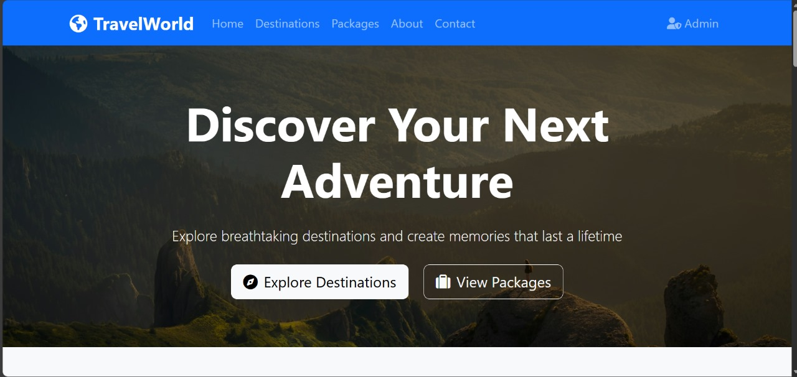

HOME PAGE

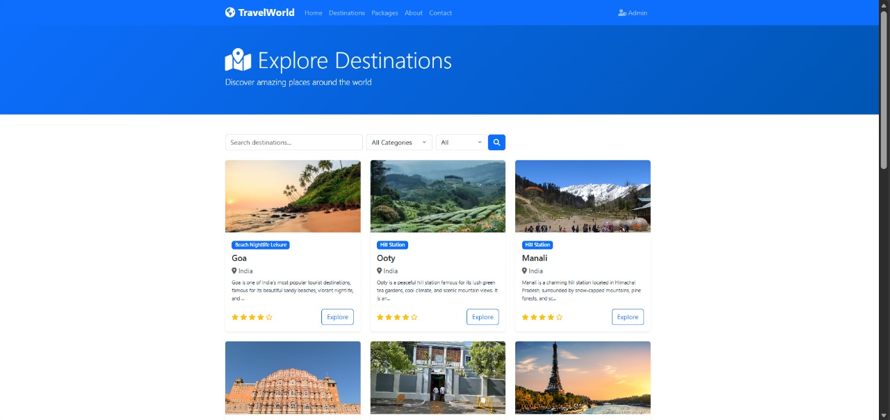

DESTINATIONS

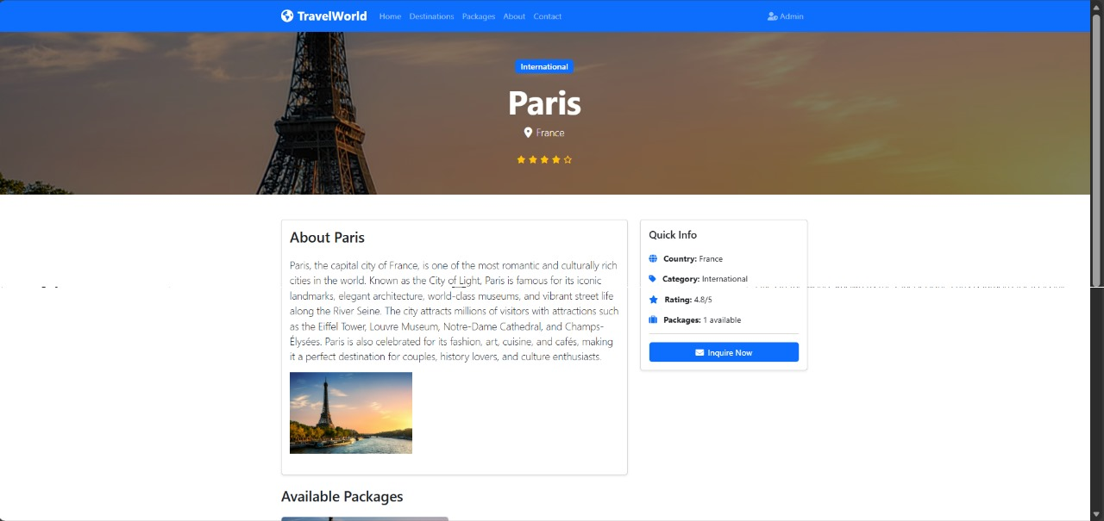

DETAILS ABOUT EACH DESTINATION

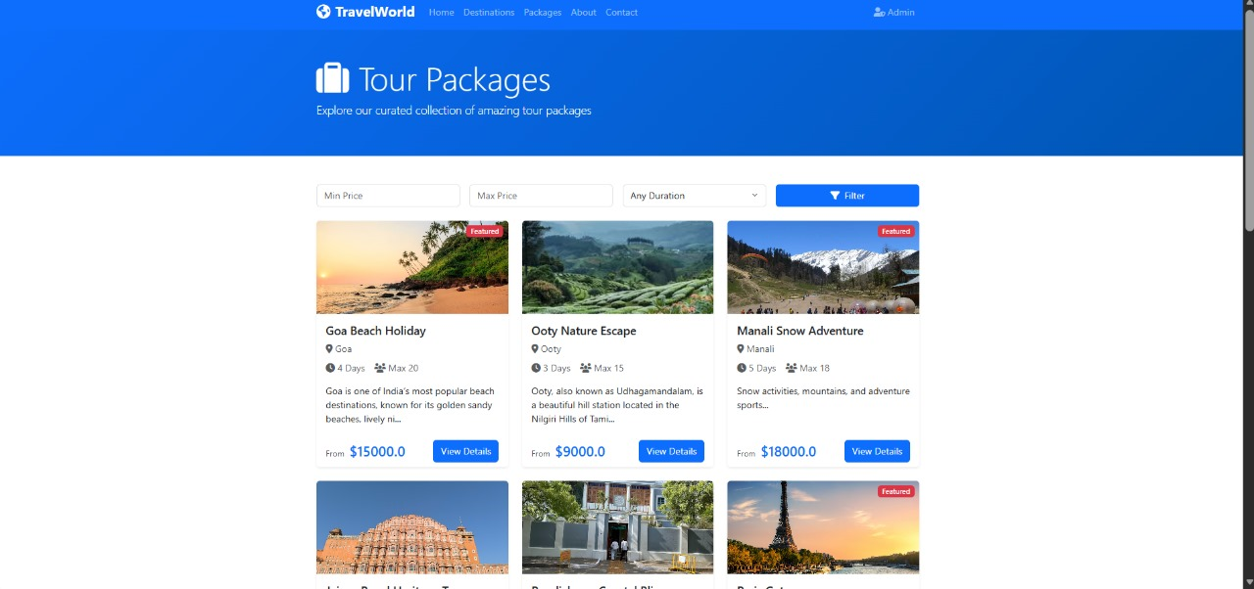

TOUR PACKAGES

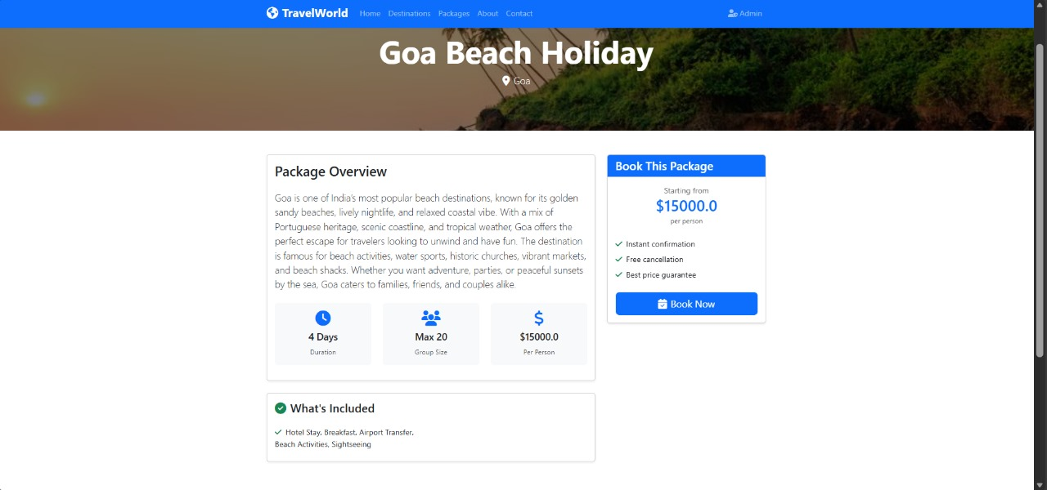

DESTINATION PACKAGE DEATILS

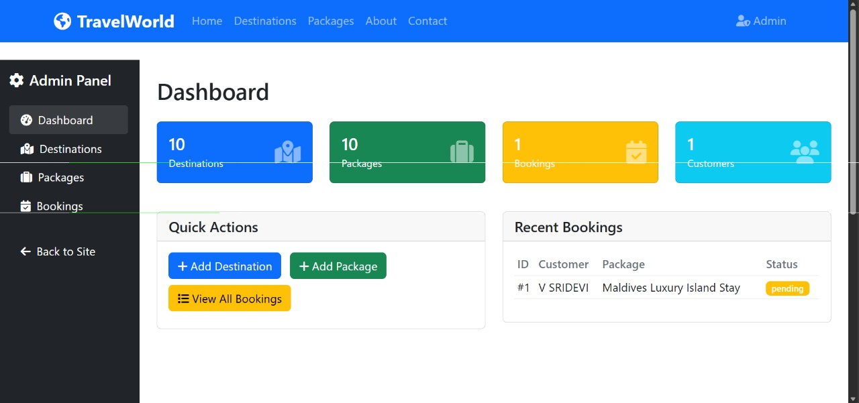
USER DASHBOARD

REFERENCES

• Python Software Foundation, Python Enhancement Proposals (PEPs), Available at: https://peps.python.org
• Flask Mega-Tutorial by Miguel Grinberg, Flask Web Development Guide, Available at: https://blog.miguelgrinberg.com
• Django Girls Tutorial, Web Development with Django, Available at: https://tutorial.djangogirls.org
• OWASP Foundation, Web Application Security Guidelines, Available at: https://owasp.org
• IBM Documentation, Introduction to Web Application Architecture, IBM Knowledge Center.
• Google Developers, Web Fundamentals, Available at: https://developers.google.com/web
• Stack Overflow Documentation, Python and Web Development Community Discussions, Available at: https://stackoverflow.com
• IEEE Xplore Digital Library, Research Articles on Web-Based Systems, IEEE Publications.
• Khan Academy, Introduction to Computer Programming and Web Development,

